CASAS Practice Template-27/28

Topic: Healthy Living

1. | walk | wolk | wall | walk | malk
2. | fruits | fwits | fruits | frutts | fnits
  3. |  | run | sleep | sit | ride
CASAS Practice Template-27/28

Topic: Nutrition

1. | 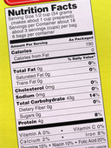 | food name | nutrition label | cooking directions | ingredients list
2. | calories | colaries | calonies | cabries | calories
3. | 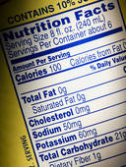 | fat | salt | food | sugar

CASAS Practice Template-27/28

Topic: Cooking

1. | 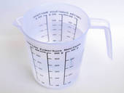 | measuring cup | measuring spoon | mixing bowl | frying pan
2. | 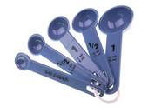 | measuring cups | baking pans | measuring spoons | cooking pots
3. | stir | stin | slur | stir | slue

CASAS Practice Template-27/28

Topic: Restaurants

1.  Lunch Menu  Hamburger $3.00 |  | 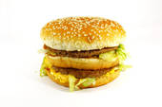$3.00 | $0.30 | $30.00 | $300
2. | 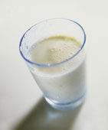 | $10 | $100 | $1 | $110
2. | $1.00
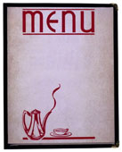  3. |  | bill | receipt | table | menu

